

20th January 2017
DALTON PIERCY RESIDENTS NEWSLETTER : 2

This newsletter follows on from our first issued in November last year and provides an update on progress with the strategic project to improve the resilience of supplies of water to the Wynyard area. To recap, we are providing a pumping station at Dalton Piercy and laying around 5 km of new water pipe (mains) from the Dalton Piercy treatment works, under the A19 to the boundary of Wynyard. The value of this investment is around £3.4m.

Both parts of our works are progressing well and to timetable having made good progress since our last newsletter.

PUMPING STATION
To ensure the water meets pressure standards, we have installed a new pumping station to boost the water over the hill in to the Wynyard area. The pumping station was delivered to site on 14th December. An escort vehicle was available to stop traffic for the few minutes the load took to come off the A19, through the village and onto our site. Given concerns raised by the Parish Council about the bridge in the village, we liaised with Hartlepool Borough Council and had an Engineer on site to witness the movement of the load over the bridge and no issues arose. The new building has five pumps to cater both for maintenance and extra water demand expected in the Wynyard area over the next 20 years.

The new pumping station has been connected for both water and power and is now subject to rigorous testing in the coming weeks to ensure that it meets all design expectations. The large battery pack has also been fitted to reduce the risk of short term water supply failures if we lose power supplies from the national grid.

We have kept all excavated soil from the pumping station on site and will landscape this across a wider area in better weather to reduce the numbers of lorry movements through the village. This has now saved around 30 lorry loads of soil having to be moved off the site during construction.

We have re-briefed all drivers to stick to both the 20mph village speed limit and the site road limit of 10mph and briefings have been sent to our suppliers to remind drivers who bring goods to site to stay within the law. Again, if you see anyone speeding who you believe is linked to our project, please let us know.

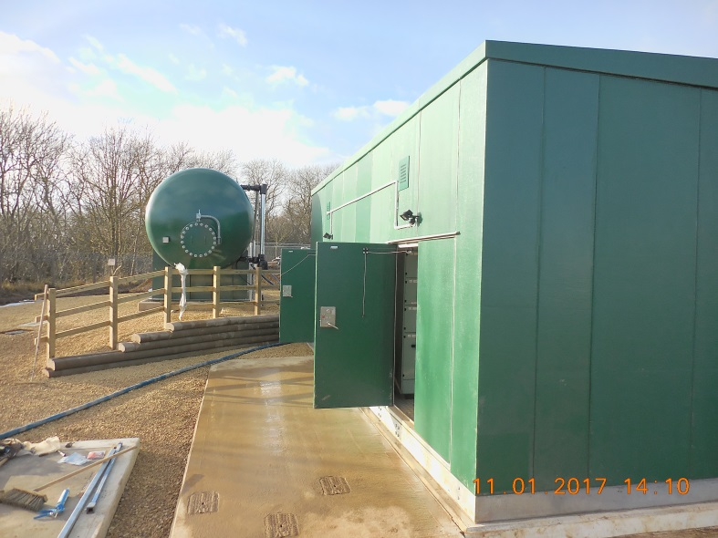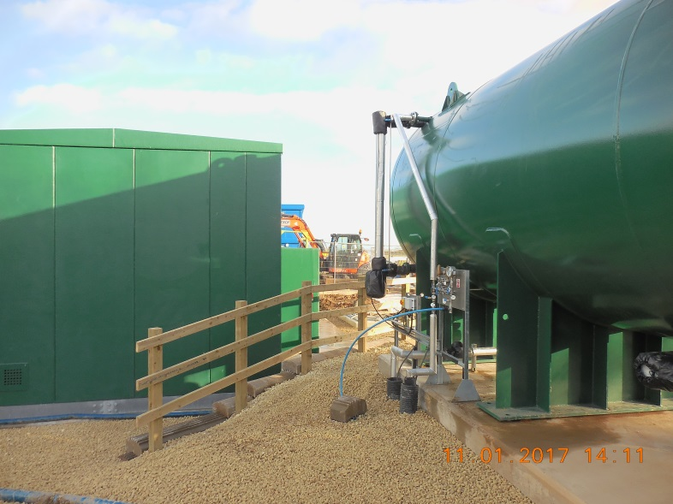
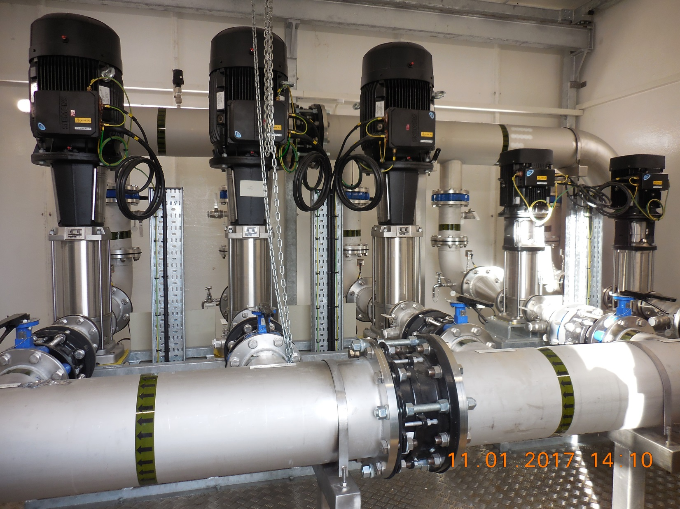

WATER MAINS
The new 350mm diameter pipe has been completed across farmland for all of the 5km distance. We have crossed the beck at Dalton Village, laid pipe behind the south side of the village, drilled pipe under the A19 trunk road and past the two sites containing crested newts. Progress has been good with the final section of pipe having been laid behind “The Grove” this week. Topsoil will not be replaced anywhere on the pipeline route until the weather improves and the fields dry off to avoid damage to the soil structures and to reduce risk of mud. The pipeline route will therefore remain as a scar across the early crops in the fields for the next few weeks. Topsoil is located next to the pipe track so does not require to be transported by lorry.

We have also stopped using the pipe storage area to the west of the village this week so we will no longer carry pipe lengths through the village and bring mud off this track. A street cleaner has been passing through the village and up our site roads on a daily or twice daily basis when pipe has been moved to reduce the amount of mud on the roads.

We hope that you may again find this update helpful. The project remains on time to put water into supply by the end of March 2017 at the latest.

FUTURE PROJECT

We received planning permission late last year to build some pressure filters at the northern end of our site with 2 ancillary, single-story buildings. This project has a value of over £6m and has been designed to remove trace levels of iron and manganese from the borehole sources waters which arrive into the treatment works from the western wellfield near Sedgefield. Whilst not harmful to health, these trace metals can be the cause of discoloured water and particles in the water from time to time. This new treatment process is part of a long term strategy we are developing to reduce the risk of discoloured water arriving at customer taps which has been agreed with our water quality regulator, the Drinking Water Inspectorate. The provisional completion date for the filtration system is expected to be late April 2018.

Design work is at an advanced stage and we expect our civil engineering contractor to start work on site in mid February. All the building processes for this scheme are within our site boundary with no works being needed outside our site. We are developing a transport plan to understand the number and frequency of lorry movements into the site and will take into account the concerns raised by the Parish Council about reducing the number of delivery vehicles coming through the village and ensuring we use other routes where these are practical for the loads concerned.


Thank you for taking the time to read this update note and for your patience and understanding whilst we carry out this vital work near your home. It is important to us that we keep all of our neighbours informed about what we are doing on our site so another newsletter will be issued to the Parish Council in late April once the Wynyard pipeline project is completed and the filtration project started. If you have any questions about this project or the one starting in February, then please contact us at enquiries@hartlepoolwater.co.uk or by telephone during office hours on 01429 858050 and one of the team looking after this project will contact you.

Yours sincerely,

K J Ensell
Strategic Water Operations Manager

