

26th April 2017
DALTON PIERCY RESIDENTS NEWSLETTER : 3

This newsletter follows on from our second issued in January and provides an update on progress on two projects:

- Our project to improve the resilience of supplies of water to the Wynyard area.
- Our project to install extra water treatment to remove trace levels of iron & manganese from the borehole waters; a potential source of discoloured water for customers.

Wynyard Project

To recap, the project was designed to provide a pumping station at Dalton Piercy and to lay around 5 km of new water pipe (mains) from the Dalton Piercy treatment works, around your village and under the A19 to the boundary of Wynyard. The value of this investment was around £3.4m.

The pumping station was delivered in December and was fully commissioned to pump water through the new pipeline around the village in late February. This was one month ahead of schedule which was great news for both the construction team and the customers on this new supply.

The supply has run smoothly to date and is being monitored continuously to ensure the system delivers what it was designed to do.

We kept all excavated soil from the pumping station on site and have landscaped the soil on site which reduced the numbers of lorry movements out of our site and through the village.

We have still to replace all the topsoil along the pipe 5 km route as this can only be done when the soil has dried out. This will be starting soon but again we emphasise that the soil is alongside the pipe route and only needs spreading so will not create lorry movements apart from the hauling of plant to and from site at the start and finish of the works.
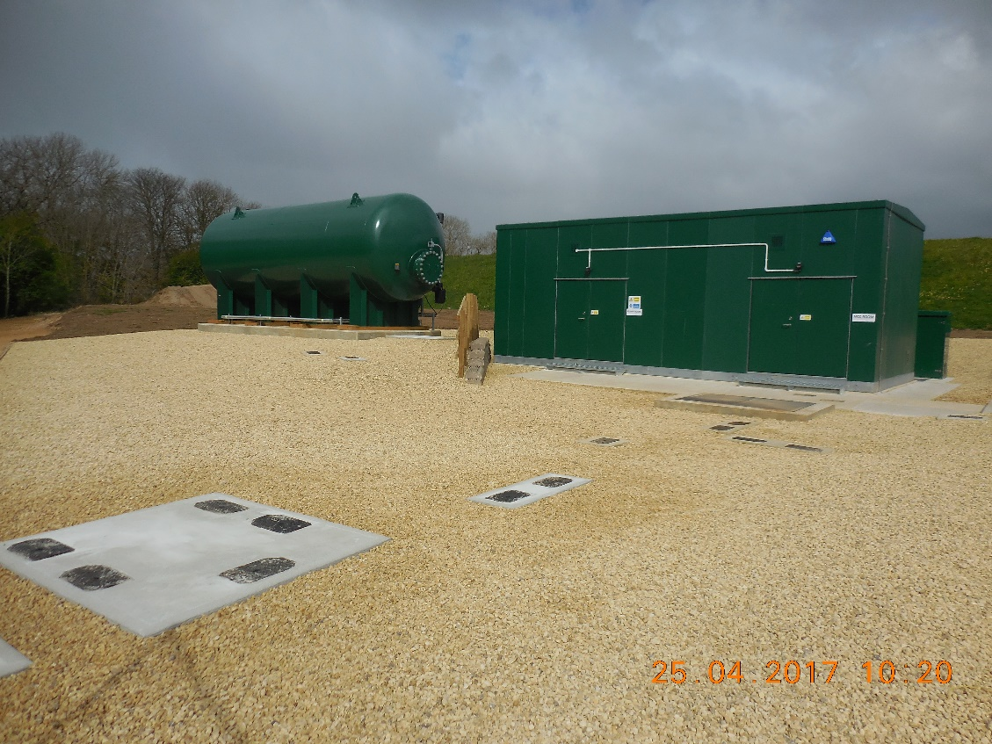

Treatment Project

To recap, we received planning permission late last year to build some pressure filters at the northern end of our site with two small, single-story buildings. This project has a value of over £6m and has been designed to remove trace levels of iron and manganese from the borehole sources waters which arrive into the treatment works from the western wellfield near Sedgefield. Whilst not harmful to health, these trace metals can be the cause of discoloured water and particles in the water from time to time. The completion date for the filtration system is expected to be late April 2018 with the bulk of the construction work being completed by the end of 2017.

Our civil engineering contractor started work on site in early March preparing the foundations for the filtration equipment and this phase is progressing well given recent good weather. All the building works for this scheme are within our site boundary. We have developed a transport plan to reduce lorry movements into the site and have taken into account the concerns raised by the Parish Council about reducing the number of delivery vehicles coming through the village and ensuring we use other routes where these are practicable. As an example, all our stone has been sourced from nearby Hart Quarry and the many lorry loads have come to site from the East. We are also working with our suppliers to bring some materials in via Hartlepool. We do have some bulky but relatively light loads due in the early summer when the steel pressure vessels arrive on site and these will need to come through the village. We will provide plenty of notice and sufficient road signage to warn residents and road users of these escorted loads which will need to pass briefly through the village owing to overhanging, mature tree branches to the East.
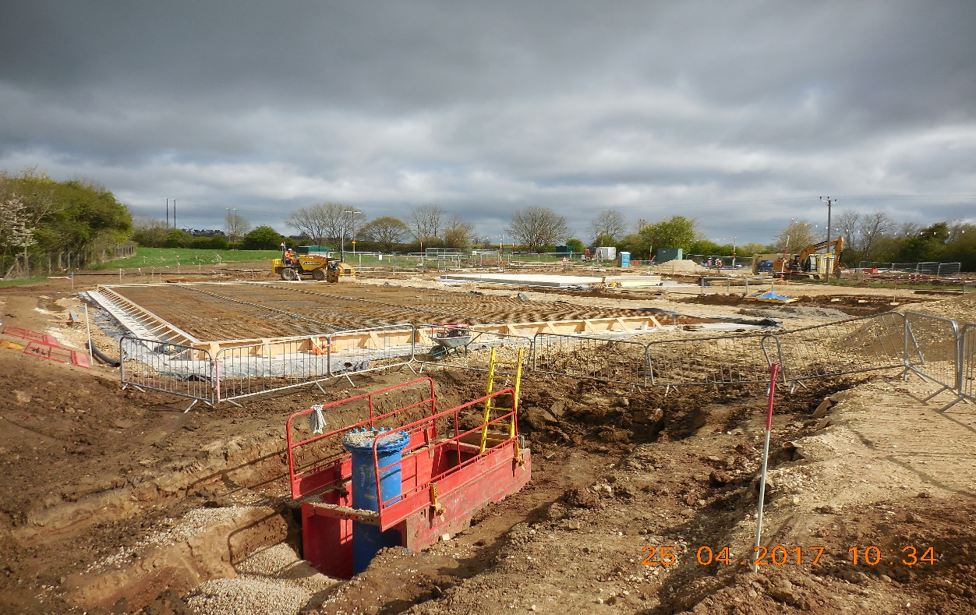

Thank you for taking the time to read this update and for your patience and understanding whilst we carry out this vital work near your home. It is important to us that we keep all of our neighbours informed about what we are doing on our site so another newsletter will be issued to the Parish Council in July when progress on the treatment project is further ahead. If you have any questions about the treatment project, then please contact us at enquiries@hartlepoolwater.co.uk or by telephone during office hours on 01429 858050 and one of the team looking after this project will contact you.

Yours sincerely,
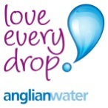

K J Ensell
Strategic Water Operations Manager

