

5th September 2017

DALTON PIERCY RESIDENTS NEWSLETTER : 4

This newsletter follows on from our third newsletter issued in April and provides you with an update on progress on our project to install extra water treatment at our Dalton Piercy water treatment works.

Treatment Project

You may recall that we received planning permission late last year to build some pressure filters at the northern end of our site with two small, single-story buildings. This project has a value of over £6m and has been designed to remove trace levels of iron and manganese from the borehole source waters which arrive into the treatment works from the western wellfield near Sedgefield. Whilst not harmful to health, these trace metals can be the cause of discoloured water and particles in the water from time to time. The expected completion date for the filtration system remains late April 2018 with the bulk of the construction work being completed by the end of 2017.

We have made very good progress to date making best of the weather during the summer months. Almost all of the civil works are now completed including all the underground pipes, drains, concrete pads and roads across the northern end of our site. We have some finishing work to do but this phase should be completed by mid September.

To keep to our plan, some tanks have been already been erected to store the waste water created by the filtration system and pipework to connect these tanks is being installed this week. A crane may be seen on site to assist in lifting some heavy equipment.
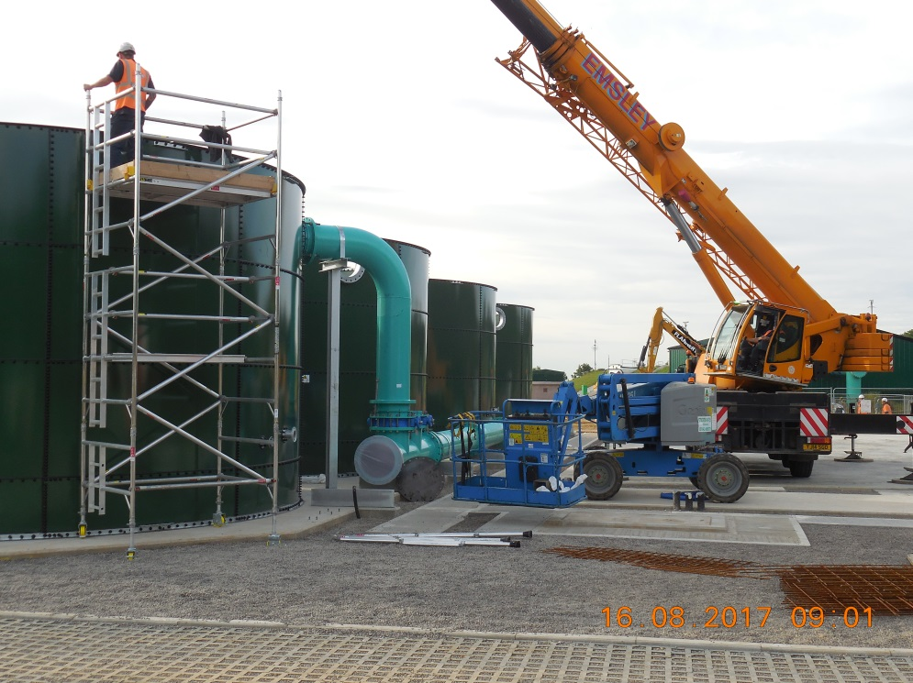
Throughout our programme, we have managed our deliveries carefully and have a transport plan in place to minimise any impacts of lorries passing through your village. The civil construction phase mentioned above included nearly 300 lorry loads of stone and concrete. In almost all cases, these deliveries came to site from the East therefore avoiding them passing through the village. We will continue to work with our suppliers to make sure we respect the wishes expressed by the Parish Council to reduce the impact of our work on the local community. We hope you will also be reassured that we take transport matters seriously.

We will shortly have some very bulky loads delivered to site consisting of 10 large steel vessels plus their cradles. These were manufactured in Oldbury in the West Midlands and will need to pass through the village from the A19 owing to their sheer size. This is to avoid overhanging trees to the East which cannot be pruned. We expect deliveries each week throughout September and October. The timing of these large loads will avoid the morning rush hour and the lorries will have escorts. We will also provide roadside warnings showing the timing of these deliveries each time they are planned so residents are aware in advance should anyone have important appointments to meet. The loads are not especially heavy just large in size and will take only minutes to pass through.

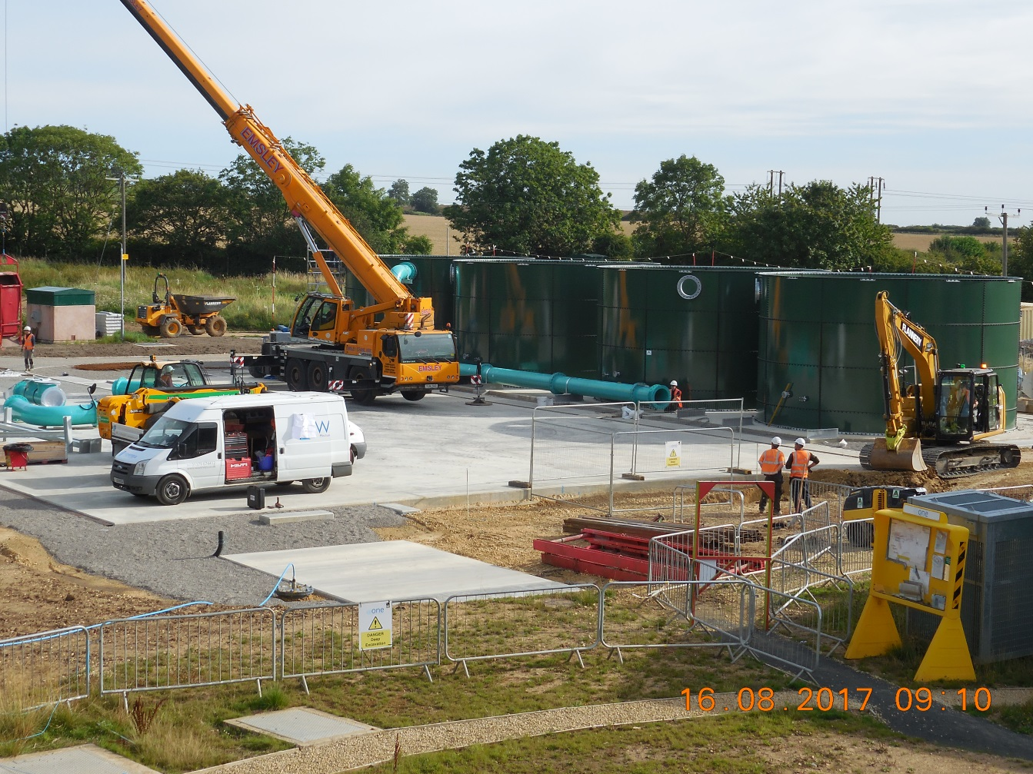

Thank you again for taking the time to read this important update and for your continued patience and understanding whilst we carry out this vital work near your home. It is important to us that we keep all of our neighbours informed about what we are doing on our site so another newsletter will be issued to the Parish Council later in the year when progress on the treatment project is further ahead. If you have any questions about the treatment project, then please contact us at enquiries@hartlepoolwater.co.uk or by telephone during office hours on 01429 858050 and one of the team looking after this project will contact you.

Yours sincerely,
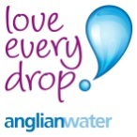

K J Ensell
Strategic Water Operations Manager

